Supplemental Guidance and Research Notes Related to Walk Signal Policies
Prepared for Discussion of Walk Signal Policies at 11-21-22 GCSC meeting

NCHRP Report 969: Traffic Signal Control Strategies for Pedestrians and Bicyclists, 2022
There are several strategies to improve pedestrian and bicycle safety by reducing conflicts with turning vehicles:
- Protected only left turns
- Concurrent-Protected Crossings (protected only left and right turns)
- Exclusive pedestrian and bicycle phases
- Leading pedestrian intervals
- Restricting right turns on red

Protected-Only Left Turns. This treatment examines whether left turns should be protected-only—that is, completely separated in time from conflicting traffic, including crossing pedestrians and bicycles. It reveals—perhaps more than any other treatment—a large difference in practice between North America and bicycle-friendly countries in Europe, where left turns across multilane roads are nearly always protected-only.
Protected-only left turns might be appropriate for:
• Multilane roads;
• Left turns across a two-way bike path running along a road;
• Intersections with limited visibility between approaching bicycles and left-turning vehicles
(visibility may be limited by parking, trees, etc.);
• Skew intersections that allow high-speed left turns;
• High volume of left turns; and
• High-speed roads.

In coordinated corridors with protected-only left turns, lagging left turns often lead to less
delay for left-turning vehicles because signals are typically timed for the main platoon to arrive
during the green interval. With lagging left turns, most of the vehicles arriving in the main platoon
are served toward the end of their arrival phase, while with leading left turns, they have to
wait for the next cycle.

Concurrent-Protected Crossings. Both right turns and left turns are given their own distinct phases, controlled by turn arrows, while pedestrians and bicycles cross concurrently with parallel through traffic. The main drawback to this treatment is that it requires an exclusive right-turn lane as well as an exclusive left-turn lane.
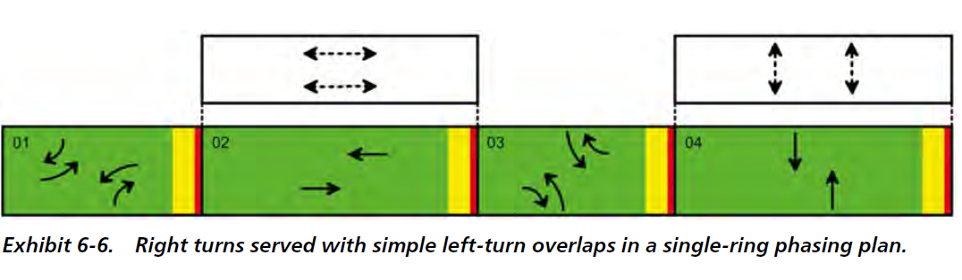
There is no national guideline for an acceptable volume of permitted right-turn conflicts. Both the State of Massachusetts and Boston recommend protected pedestrian crossings where concurrent right turns would exceed 250 vehicles per hour (which is approximately seven vehicles per cycle, since most intersections have a cycle length of 100 s). The right-turn volume threshold for preferring fully protected versus partially protected crossings is 200 vehicles per hour for New York City. In Montreal, that threshold is 200 vehicles per hour where the crossing length is 20 m (67 ft) or more. For shorter crossings, the threshold increases to 500 vehicles per hour where the crossing length is 8 m (27 ft) or less.
From the MassDOT separated bike lane design guide. If left or right turns across a bike lane exceed these thresholds, they need to have protected only phases
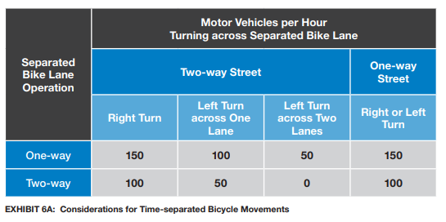
Exclusive Pedestrian and Bicycle Phases. There is one phase in the cycle for all pedestrian movements; that phase may or may not serve bicycles as well. The main drawback is its negative impact on traffic capacity, as it can force signal cycles to be long and lead to high delay for all users, including pedestrians.

If exclusive pedestrian phases are provided, pedestrians can also be allowed to cross concurrently
(i.e., concurrent with the parallel vehicular movement). This option results in high pedestrian-crossing capacity and less waiting time for pedestrians, but pedestrians are not protected from permitted turns during concurrent phases.

There are several contexts for which exclusive pedestrian or bicycle phases might be appropriate:
• Where either high-speed right turns, a high volume of right turns, or frequent right-turning
trucks make concurrent crossings unsafe, and it is not possible to provide a dedicated right turn
lane;
• At intersections with very high pedestrian-volumes (greater than 1200 per day)—as might be common near a busy transit station—where concurrent crossings would conflict with right-turning traffic to the point of creating tension and/or overly restricting right-turn capacity;
• At intersections with very high pedestrian-volumes—where pedestrians need the green for a
large part of the cycle—by combining an exclusive pedestrian phase with concurrent crossings
• Where there is high demand for diagonal pedestrian crossings; or
• To serve an important diagonal bicycle crossing, such as when a bicycle path switches from
one side of the road to another.

Exclusive pedestrian phases are used widely in North American cities, most often in downtowns. In Massachusetts, exclusive pedestrian phases have long been the default treatment for intersections on state highways, and they are also common at local, municipal intersections. However, they typically involve long pedestrian waiting times and poor pedestrian compliance; therefore, pedestrian advocates generally prefer concurrent crossings, except where right-turn volumes are high or turns are made at high speeds due to intersection geometry.

The Toronto Transportation Division developed the following guidelines for implementing
exclusive pedestrian phases. The treatment should be implemented only if one or more of the
following conditions are satisfied:
• The intersection experiences a high volume of pedestrians (3,000 for an 8-hour period).
• There is a combination of a moderate volume of pedestrians (2,000 for an 8-hour period) with high turning-vehicle volumes (30% of the total vehicular traffic).
• There is moderate pedestrian volume with high pedestrian–vehicle collisions (three collisions
over the past 3 years).
• There is moderate pedestrian volume, and 25% of pedestrians desire to cross diagonally.
• The intersection geometry is unusual (e.g., highly skewed; five or six legs).

Leading Pedestrian Intervals. At the start of a vehicular phase, all traffic is held for a short time while pedestrians—and bicycles in certain cities—get a head start, allowing them to establish their priority in the crosswalk before turning traffic is released.

An LPI might be appropriate where pedestrian crossings are concurrent with a parallel vehicular phase, where right turns (in this report, “right turns” also includes left turns from a one-way street) are permitted to conflict with crossings, and the following four criteria are met:
1. There is no exclusive right-turn lane. If there is a right-turn lane, it is more appropriate to
use the delayed-turn technique, which holds turning vehicles while allowing through vehicles to run during the leading interval.
2. The intersection layout fails to give pedestrians an adequate head start in space. When the
vehicular stop line is set back approximately 50 ft from the curb where pedestrians wait—
often called a “protected intersection” layout, pedestrians get a head start in space.
3. Conflicting right-turn volume is low or moderate. When right-turn volume is high, there will
be a lot of conflict between pedestrians and turning vehicles, even with an LPI. Therefore, in
such cases it may be more appropriate to use a treatment that provides a fully protected crossing, such as concurrent-protected phasing, exclusive pedestrian phases.
4. There is any level of pedestrian volume. Where pedestrian volumes are low, pedestrian phases can be actuated—with the LPI occurring only when a pedestrian phase runs—thus avoiding unnecessary delays on vehicle traffic.

An LPI might also be appropriate when these four criteria are met and there are T-junctions or junctions with one-way streets that have no opposing through traffic to shield pedestrians from left turns during the early part of the pedestrian phase. An LPI can be considered as a means of partial protection from left turns in these cases; however, a longer LPI may be required.

In North America, the typical length of an LPI is 3 to 7 s. In New York City and Montreal,
most LPIs last 7 s; in Cambridge and Washington, DC, they commonly last 3 s. As U.S. cities reconstruct intersections with corner bulb-outs, protected bike lanes, and other features that help create a substantial setback of the vehicular stop line relative to the curb where pedestrians wait to cross, they may also find that they can use shorter LPIs to accomplish their objective.

LPI Warrant Threshold (Adapted from Pei-Sung et. al, Development of Statewide Guidelines for Implementing Leading Pedestrian Intervals in Florida)

Warrant | Turning Vehicle Volume (A) | Pedestrian Volume (B)
Vehicle Peak Hour | ≥ 130 per hour | ≥ 25 per hour
Pedestrian Peak Hour | ≥ 100 per hour | ≥ 50 per hour
4-hour vehicle/ped volume | ≥ 105 per hour | ≥ 30 per hour
8-hour vehicle/ped volume | ≥ 100 per hour | ≥ 25 per hour
School Crossing | ≥ 50 per hour

No Turn on Red. This well-known treatment supplements several other treatments described in this guidebook, such as LPI, by giving pedestrians a short interval free of turning conflicts. NTOR addresses not only collisions with crossing pedestrians and bicycles, but also the inconvenience and hazard that occurs when right-turning drivers block the crosswalk while checking for a sufficient gap in traffic to finish their turn. Drivers often wait with their gaze fixed to their left, which may keep them from noticing a pedestrian or bicycle approaching from their right—even when the crossing person is directly in front of the vehicle—creating a high-risk situation, especially for pedestrians or bicycles with a low profile such as children and people in wheelchairs.

NTOR can be implemented with time restrictions (e.g., 7 a.m. to 7 p.m.) or “when pedestrians are present.” It can also be applied during certain phases of a signal cycle by using dynamic blank-out signs.

Some contexts in which NTOR may be appropriate to protect pedestrians and bicycles include:
• Crossings with a moderate or high pedestrian-/bicycle-volume or with a significant volume
of vulnerable crossers (e.g., children or older adults);
• Where the crosswalk location is such that drivers turning right block the crosswalk while
waiting for a gap; and
• Crossings used by bicycles approaching from the right side (e.g., from a two-way path).
NTOR is also necessary in conjunction with LPI, exclusive pedestrian/bicycle phases, and concurrent-protected crossings. These treatments all aim to hold right-turning vehicles during certain phases, so NTOR should be in effect during those phases.

NITC Improving Walkability Through Control Strategies at Signalized Intersections, 2017

The results from this research show that certain pedestrian control strategies can be successfully
used at signalized intersections to reduce pedestrian delay without negatively impacting vehicle
delays. Below are the key recommendations:
• Free operation was shown to reduce pedestrian delays significantly; however, it may not
be applicable in situations where vehicular movement along major streets is the priority.
It may be best suited for intersections where either the major- and minor-street volumes
are similar, or it could be applied selectively based on time of day.
• Coordinating major corridors to prioritize vehicular movements during peak periods may
be warranted to facilitate higher demands. However, if cities want to prioritize pedestrian
movements, removing signal coordination during the off-peak periods when major-street
traffic volumes are lower may be beneficial for balancing user priorities.
• If jurisdictions want to operate in coordinated mode, employing shorter cycle lengths can
reduce pedestrian delays for the minor-street pedestrian phases. However, the tradeoff of
increased major-street vehicle delay should be taken into consideration. Another strategy to reduce pedestrian delay is to actuate a portion of the coordinated phase.
• Leading pedestrian intervals may be used to increase the visibility of the pedestrians;
however, vehicle delay increases due to lost time for vehicles. They may be most applicable at intersections with high crash rates for pedestrians and turning vehicles. They may also be useful at offset intersections, where visibility of pedestrians may be an issue.
• Exclusive pedestrian phases increases safety for pedestrian crossings by removing all conflicts with vehicles; however, delays for all modes increase significantly. Previous research has
shown increased noncompliance as a result of the increased delays. Hence this strategy should be used only in situations where pedestrian volumes are high and safety is a critical concern.

Generally, there is no one “right solution” for all situations. Implementation of a control strategy
depends upon operational objectives and intersection characteristics. Ultimately, tradeoffs in
delays between user groups may be warranted to prioritize different modes based on time of day

Boston Region Metropolitan Planning Organization (MPO) Pedestrian Signal Phasing Study
https://www.ctps.org/data/html/studies/bikeped/ped_signal_phase/Literature_Pedestrian_Signal.html
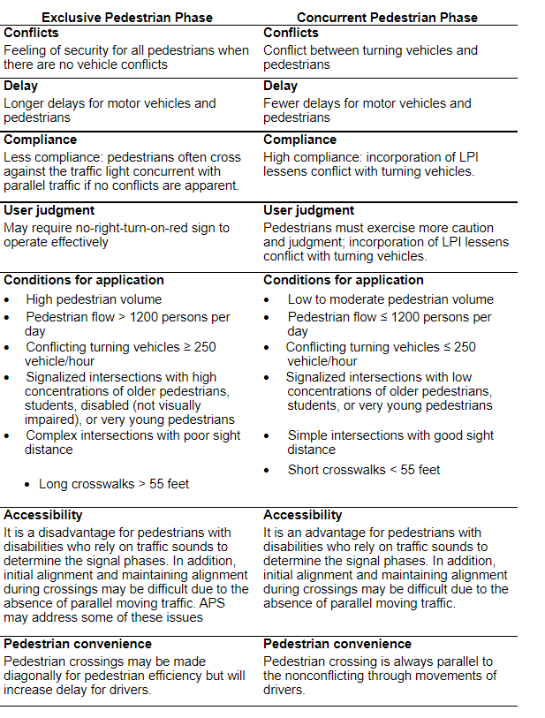

Respectfully submitted by Chair Rosie Jaswal.

