

REQUEST FOR PROPOSALS
FOR THE REDEVELOPMENT
OF THE
PROVIDENCE NEIGHBORHOOD LAND BANK PARCEL
LOCATED AT
246 PRAIRIE AVENUE (FORMER URBAN LEAGUE SITE)
PROVIDENCE, RI 02905 (PLAT 45/LOT 911)

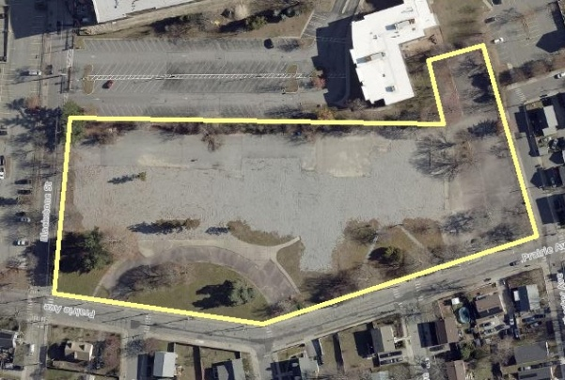

Submission Deadline: Friday December 4th, 2026
OVERVIEW
Through this Request for Proposals (“RFP”), The Providence Redevelopment Agency (the “Agency”) seeks a partner (Designated Developer) for the redevelopment of 246 Prairie Avenue, also known as the Former Urban League Site (the Property). The Agency seeks proposals from interested parties (Respondents) for a combination of uses that enhance both the South Providence neighborhood and the City of Providence overall.

With a mission to foster economic growth, revitalize neighborhoods, and guide strategic investments, the Agency serves as the City of Providence’s primary real estate and redevelopment arm. In addition to managing redevelopment projects, the Agency coordinates closely with other city departments to advance planning goals through a suite of tools and ensure that projects deliver long-term public benefit.

The Agency acquired the Property in 2022 as part of a broader initiative to position key parcels for transformative, community-oriented development. The Agency now seeks a qualified development partner to realize the Property’s highest and best use, bringing forward a project that meets market demand while furthering the City’s economic, social, and design objectives.

SCHEDULE
Request for Proposals Issued: Tuesday September 22nd, 2026
Declaration of Intent Due: Friday November 6th, 2026
Questions Due: Questions are received and responded to on a rolling basis, but must be received by no later than Friday November 20th, 2026
Proposals Due: Friday December 4th, 2026
Anticipated Award: Winter/Spring 2027

SUPPLEMENTAL INFORMATION EXHIBITS
Ex. 1. Summary Report and Marketing Flyer
Ex. 2. Community Workshop Series Summary Report (Studio Enée, July 2025)
Ex. 3. Neighborhood Amenity, Demographic, Historical, and Market Analyses (Roderick Taylor, Harvard Kennedy School, 2004)
Ex. 4. Remedial Action Workplan (Fuss & O’Neil, February 2024)
Ex. 5. Remedial Approval Letter (RIDEM, February 2024)
Ex. 6. Class I Boundary Survey and Existing Conditions Plan (Douglas Design Group, October 2025)
Ex. 7. Development Program Tables

This supplement package is available in a downloadable format on the PRA website, and may also be shared via SharePoint by request by emailing Erin Bradley at ebradley@providenceri.gov. Limited hard copies are available by request.

SITE BACKGROUND
The Property was originally developed as multiple mixed-use parcels within Providence’s South Providence neighborhood, including portions of the former Willard Ave commercial district. In 1954, the Property became part of the city’s first “urban renewal” project. Historic buildings were razed and replaced by a short-lived shopping center, before once again being redeveloped as the headquarters of the Urban League of Rhode Island—a vital resource that served the community for decades. In 2022, the Property was directly acquired and land-banked by the Agency in the City’s Neighborhood Land Bank through a combination of U.S. Dept. of Housing and Urban Development, Agency, and American Rescue Plan Act funds. The Agency cleared the site of its structures, conducted environmental analysis and facilitated a Remedial Action Work Plan (included in this RFP). Spanning over a year, a robust community engagement process was undertaken (the findings of which are included as a supplement). The Property is now poised for redevelopment in accordance with that community vision.

The site is located in the South Providence neighborhood, also known as “the South Side,” and in planning designations formally as “Upper South Providence.” It is adjacent to what is commonly referred to as the “Hospital District” sub-neighborhood. South Providence is a dynamic neighborhood with a deep sense of community and a strong network of institutions, businesses, and cultural resources. Home to major healthcare and educational anchors, local small businesses, and a diverse residential community, it offers both stability and opportunity for growth. The neighborhood’s civic and cultural organizations, and accessible location within the city, make it a place of connection and resilience, where new investment can build upon existing strengths to serve residents and the broader Providence community.

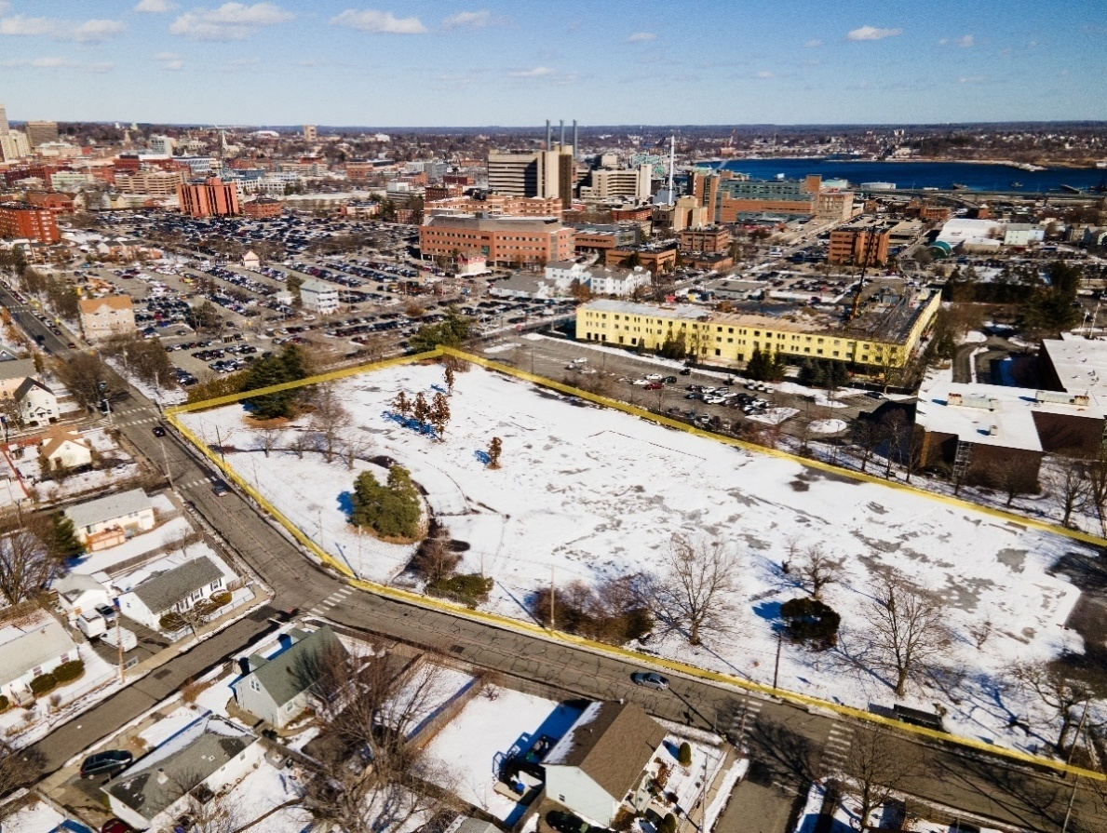
The Property (with a yellow border) and South Providence neighborhood in foreground
The Hospital District is in the background

The Hospital District, within South Providence, is home to three Brown University-affiliated teaching hospitals: Rhode Island Hospital (the largest medical center in the region), Hasbro Children’s Hospital, and Women & Infants Hospital; along with related uses such as medical offices and outpatient facilities. This area has close economic ties to the Jewelry District, located just across I-95, where Brown University’s Alpert Medical School, Brown University’s administration, the Rhode Island Nursing Education Center, and various life science uses, are located. The redevelopment of the Hospital District into a more multi-dimensional area is a significant community priority, and efforts are underway to restore the area’s urban fabric and better integrate medical, educational, residential, commercial, and community uses.
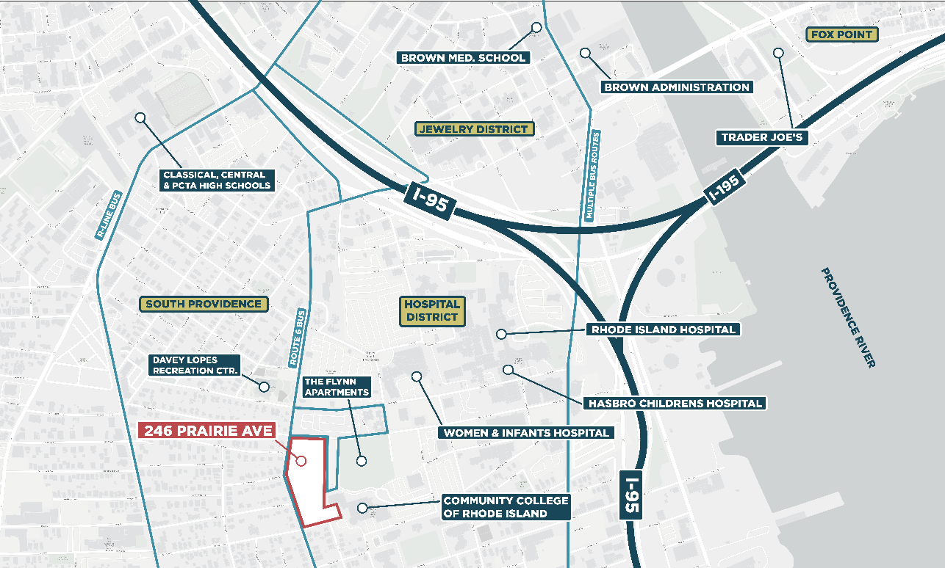
Context map showing the Property and nearby institutions

ZONING
The site is zoned C-3 “Heavy Commercial District.” This zoning allows for a mix of uses on-site, including residential, multi-tenant retail, and other commercial uses. See the City of Providence Zoning Ordinance for more clarification (commercial district information starts on page 44).

SITE VISIT
The Property is currently secured. Site visits may be scheduled by request by emailing Erin Bradley, ebradley@providenceri.gov. Most aspects of the site are visible from the public right of way.

DECLARATION OF INTENT TO BID
Prospective proposers are requested to inform PRA by Friday November 6th, 2026 of their (non-binding, optional) intention to submit a bid via email to Nicholas Cicchitelli, Director of Real Estate, at ncicchitelli@providenceri.gov.

DEVELOPMENT OBJECTIVES
The Agency seeks proposals from qualified developers for any combination of uses that align with Agency’s objectives. Some considerations for preferences at the Property include the following:
- Guided by the community outreach that concluded in Summer 2025 which identified multiple preferred uses (see Ex. 2.), it is expected that the successful proposal will contain a mix of responsive and beneficial uses on the 4.6-acre site.
- Given the regional housing crisis, projects offering a significant quantity of housing are preferred. However, any successful project must contain a component of affordable housing for Rhode Islanders earning 80% of area median income (AMI) or below.
  - For the housing component(s), a balanced mix of market-rate, workforce, and affordable housing units is preferred in furtherance of the City’s Anti-Displacement and Comprehensive Housing Strategy goals and the stated preferences captured during the community engagement process.
- The Agency will consider proposals that offer either fee simple land acquisition(s), or ground lease(s), with terms and conditions considered on a holistic basis.
- Projects that contribute significantly to city tax revenue on an ongoing basis are preferred.
- Design excellence should be prioritized, including considerations of:
  - Quality architecture, with specific consideration of materiality and façade composition.
  - Quality urban design and site planning, including: permeability through the Property and connections to adjacent institutions, public open space, links to the surrounding street grid, and proper treatment of key corners of the Property including opportunities for public art collaboration with the community and City.
  - Open space and intentional landscaping.
    - Preservation and improvement of existing 30-foot wide “green belt” setback along Prairie Avenue.
  - Gestures that tie together the institutional Hospital District and the residential scale of the South Providence neighborhood, including massing that is responsive to its adjacencies, with highest densities close to the north and east sides of the Property, with some massing relief closer to the Property’s south and west sides.
  - Street activation through lively ground floor uses and thoughtful urban design strategies. Where commercial uses aren’t located on the street-facing portion of the ground floor, residential units opening directly to the outside are encouraged.
  - Thoughtful considerations of service access, including loading, parking, and trash.
- The inclusion of spaces for community facilities/service-based organizations (even if specific organizations are not yet identified during the RFP process).
- The inclusion of retail amenities serving the needs of the neighborhood, especially purveyors of fresh food, that address the shortage of food services in the neighborhood (See Ex. 3.1).
- Commercial uses providing economic opportunities and amenities to both South Providence and the City of Providence overall.
PHASING
As the Property is 4.6 acres, Respondents may choose to propose a multi-phased development. Please note the following for RFP responses with multiple phases:
- Proposing a multi-phased project will neither reduce nor improve the likelihood of selection.
- In the event a multi-phased project is selected, the Property will be subdivided. Portions of the site will be sold or leased to the Designated Developer as they are “shovel-ready” for a given phase. Remaining portions of the Property will be retained by the Agency until future phases are ready for groundbreaking.
- Respondents may begin development on either the north or south portion of the parcel, at their discretion, but Respondents should be clear in their proposals about order of development phasing.
- Respondents must provide a comprehensive phasing plan covering the entire development. At a minimum, submissions must include:
  - Full phasing plan: A fully developed plan for all phases, including site design, building program, anticipated massing, building orientations and entrances, circulation, parking, open space, and site connectivity, and financing and implementation strategies.
  - Phased pro forma: A financial model that incorporates all phases broken out by each distinct phase, and an additional “rolled-up” pro forma showing the viability and return metrics of the overall project.
  - A clear description of which uses are planned for each phase. Proposals that prioritize community-serving elements (such as community space, fresh food access, and open space) in early phases will be viewed more favorably.
  - Infrastructure and site features: A delineation of infrastructure and shared site features (utilities, stormwater, open space, parking, etc.) by phase, with an explanation of how these will be delivered and maintained over time.
  - Preservation of a 30’ greenbelt buffer along Prairie Ave implemented during each phase.

NOTICE OF FUNDING AVAILABILITY
As an enticement to proposers, the Agency is reserving up to $500,000 in match funding through to the Designated Developer to off-set eligible project costs relating to inclusion of affordable housing on the site. Eligibility for this funding is tied to provision of affordable rental and/or homeownership units priced to be no more than 30% of income for households earning no more than 80% of AMI for homeownership units, and no more than 65% of AMI for rental units. All developers must guarantee (via a Land Use Restrictive Covenant or other affordability mechanism) 20 years or more of long-term continuous affordability in assisted projects. Units meeting core program requirements (income limits, tenant protections, affordability period, and housing quality standards) for federal programs, such as the Low-Income Housing Tax Credit and HOME Investment Partnerships Programs, are considered “presumptively eligible” under Agency funding.

Sections 45-31-7 and 45-32-5(11) of the Rhode Island General Laws authorize the Agency to lend money for the purpose of eliminating and preventing blighted and substandard areas through redevelopment. Chapter 13, Article III, Section 13-18 of the Providence Code of Ordinances authorizes the allocation of Program funding solely for the purpose of funding construction, development or financing mechanisms of affordable housing for rental or home ownership. Uses of funds may include customary and reasonable costs associated with the acquisition, development, redevelopment, rehabilitation, construction, and/or preservation of deed-restricted, long-term affordable housing.

Respondents seeking to avail themselves of this match funding should reflect “PRA NOFA” in their submitted sources/uses for the project.

PROPOSAL SUBMISSIONS
Proposals are due Friday December 4th, 2026 by 4:00 PM and must be submitted to Nicholas Cicchitelli, Director of Real Estate, at ncicchitelli@providenceri.gov with subject line “246 Prairie Avenue RFP.”

Hard copies are also acceptable and may be mailed or delivered to:

Providence Redevelopment Agency
Attn: Nicholas Cicchitelli, Director of Real Estate
444 Westminster Street, 3rd Floor
Providence, RI 02903

“246 Prairie Avenue RFP” should be noted on the submission package.

Late or partial submissions may be disqualified.

See Appendix A for submission requirements.

EVALUATION
Proposals will be evaluated holistically. While sales price/ground lease terms will be considered, the Agency will use a combination of qualitative and quantitative scoring methodology to determine the Designated Developer. Key evaluation criteria include the following:
- Alignment with the Agency’s goals for the Property, noted herein under “Development Objectives”
- Development team experience, qualifications, and prior work
  - Demonstrated capacity of the respondent and team to successfully complete projects of similar size, scope. Strong references and proven track record will be valued.
- Project financial feasibility and respondent’s financial capacity
- Inclusion of MWBE and local business participation
- Project schedule and implementation readiness
  - Realistic and achievable project timeline that demonstrates the proposer’s ability to proceed efficiently from acquisition through redevelopment.
The following scoring matrix will be used by the evaluation team:
Evaluation Criteria | Weight (%) | Explanation
Development team experience, qualifications, and prior work | 25% | Demonstrated capacity of the Respondent and team to successfully complete projects of similar size, scope, and historic character. Strong references and proven track record will be valued
Project financial feasibility and Respondent ’s financial capacity | 15% | Evidence that the project is financially viable and that the Respondent has adequate resources or financing commitments to bring the project to fruition
Community impact and neighborhood considerations | 20% | Impact to the community and Upper South Providence neighborhood’s economic wellbeing and quality of life
Project schedule and implementation readiness | 15% | Realistic and achievable project timeline that demonstrates the Respondent’s ability to proceed efficiently from site control through grand opening
Alignment with Agency objectives | 15% | Consistency of the concept with Agency’s planning goals, inclusion of M/WBE and local business participation
Affordable Housing Strategy | 10% | Inclusion of affordable housing on site

NEXT STEPS
- The Agency will review proposals and may follow-up with questions.
- Respondents may meet with staff or consultants to discuss their proposals.
- Either all, or a limited number of selected finalists, will give public presentations at Agency meetings and a community forum.
- The Agency staff will review projects holistically and provide a recommendation for a Designated Developer to the Agency board for a vote.
- The timeline for review is dependent upon the number of proposals received, but the Agency intends to announce award(s) in Early 2027.
- After selecting a proposal, the Designated Developer will enter into a mutually agreeable disposition contract and there will be defined due diligence and permitting periods thereafter.

APPENDIX A
SUBMISSION REQUIREMENTS

- Applicant and Team Information
  - Identify the applicant entity, regardless of legal structure (LLC, partnership, etc.), and list all principals or managing members, with names and addresses.
  - Provide contact information for any individuals or firms authorized to represent the applicant in connection with this proposal.
  - List all identified investors with an interest of 10% or more in the project.
- Project Narrative: Provide a concise overview of the proposed development, including:
- Anticipated benefits for the City of Providence, and alignment with the Agency’s mission.
- Estimated number of permanent jobs created and salary ranges for those positions.
- How the project will activate the surrounding streets and restitch urban fabric.
- Other benefits or community impacts.
- Development Team Experience
- Provide examples (3–4) of comparable projects completed by the development team or its principals, with descriptions and images/renderings. Highlight experience with urban development, financing, and public-private partnerships.
- Outline project management strategy and the experience of key project managers and principals.
- Provide qualifications of design, engineering, and construction professionals on the team, including 3–4 example projects from the architect.
- Describe property management approach (self-managed or third-party) and relevant experience.
- Identify all MBE/WBE companies on the development team.
- Development Program
- Complete the provided Development Program Chart (Appendix B).
- Provide a narrative of proposed uses and gross floor area, including number of residential units if applicable. Break this narrative out by phase if applicable.
- Outline parking strategy, including number of spaces by use, shared spaces, and how parking demand will be met (on-site, public garages, off-site agreements, etc.).
- List any non-City of Providence-owned parcels included and the applicant’s proposal.
- Multi-Phased Developments (If Applicable)
  - State order of development (e.g., north to south).
  - Provide a comprehensive phasing plan covering the entire development. At a minimum, submissions must include:
    - Full phasing plan: A fully developed plan for all phases, including site design, building program, anticipated massing, building orientations and entrances, circulation, parking, open space, and site connectivity, financing, and implementation strategy.
    - A clear description of which uses are planned for each phase.
    - Infrastructure and site features: a delineation of infrastructure and shared site features (utilities, stormwater, open space, parking, etc.) by phase, with an explanation of how these will be delivered and maintained over time.
- Zoning and Compliance
  - Summarize compliance with the City of Providence Zoning Ordinance. List any requested variances, waivers, conditional approvals, or special exceptions. Applicants are responsible for verifying compliance.
- Design Approach:
  - Summarize the design concept and rationale behind early design choices, recognizing that design will evolve. Include:
  - Proposed massing, articulation, and façade materials, and reasons for those selections.
  - Ground-level design strategy, including the approach to publicly accessible open space and the streetscape edges.
- Site and Floor Plans
- Provide conceptual diagrams showing how the project connects to and activates surrounding streets and open spaces.
- Submit a conceptual ground-floor plan showing program distribution, service and parking access, lobbies, circulation, and dimensions.
- Provide conceptual typical upper-level floor plans, showing cores and key dimensions.
- Provide a conceptual site access plan, including pedestrian, vehicular, and service/loading access.
- Outline strategies for off-site parking, if applicable.
- Building Form and Materials
- Submit a digital massing model with floor levels indicated.
- Provide conceptual cross-sections showing grades, floor heights, overall building height, setbacks, and below-grade components. At minimum: one section north-south (Blackstone Street to Chester Avenue along Prairie Avenue) and one east-west section for each building, included in the Respondent’s proposal.
- Provide at least massing markups or schematic renderings:
  - Perspective looking toward the corner of Prairie Avenue and Blackstone Street.
  - Perspective looking toward the corner of Prairie Avenue and Chester Avenue.
  - Perspective looking down Prairie Avenue from one end of the Property toward the other end.
- Provide a preliminary materials palette (façade, site, and landscape elements).
- Sustainability and Resilience
  - Describe strategies for sustainable design and operations, including energy, water, and site planning.
  - Outline measures to enhance resilience to climate change impacts.
- Development Schedule
  - Provide a detailed schedule from designation through completion, including for each distinct phase (if applicable), including due diligence, permitting, anticipated construction start, and construction duration.
- Financial Proposal (Confidential)
  - Submit an Excel pro forma with working formulas. If multiple phases, each phase should be broken out as separate pro formas, as well as a rolled-up overall pro forma. Each pro forma must include the following:
    - Sources and uses.
    - Detailed operating pro forma with separate analyses for each program component in a mixed-use project.
    - Key assumptions.
    - Key return metrics including, at the very minimum levered and unlevered IRR, and levered and unlevered return on cost.
- Describe capitalization plan and anticipated equity sources, with current status of negotiations. Provide evidence of financing commitments where secured.
- Provide logic for market analysis and revenue assumptions.
- Identify any subsidies requested from City/State/Federal sources and whether secured or unsecured Provide evidence of funding commitments where secured.
- Provide developer financial capacity, including:
  - Financial statements.
  - Pending/past litigation.
  - Written confirmation that all loans to developer’s property’s/projects are in good standing.
- Proposed land purchase price/ground lease terms, and other key terms.
- Background Checks and References
  - Respondents must certify the following. Any exceptions must be explained in writing, with circumstances and current status clearly described:
    - Neither the company nor its principals and affiliates have been:
      - Subject to personal or professional bankruptcy.
      - Convicted of a felony.
      - Are subject to any pending litigation.
    - All loans on any active projects, or on properties owned by the principals and the company and its affiliates, are in good standing.
  - Provide references from 2–3 lenders and 2–3 equity partners. The Agency reserves the right to contact additional references, including public officials in communities where the applicant has developed projects.

APPENDIX B
PROGRAM CHART
The submission of this chart is a requirement of this RFP. Please find an excel version in supplement exhibit 7.
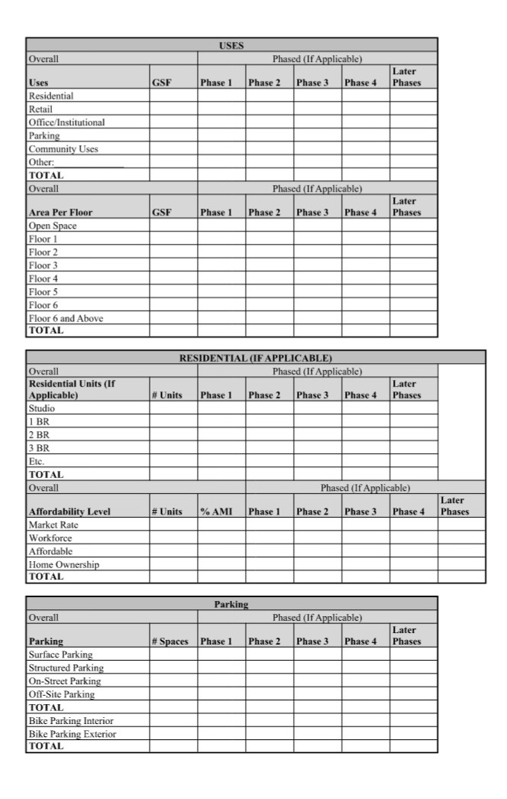
DISCLAIMERS / DISCLOSURES / STATEMENT OF LIMITATIONS / OTHER TERMS
- This RFP shall not be construed in any manner to create an obligation on the part of the Agency to enter into a contract for any purpose whatsoever, nor to implement any of the actions contemplated hereby, nor to serve as the basis for any claim whatsoever for reimbursement of costs for efforts expended in preparing a response hereto, regardless of whether the interested party is selected.
- The Agency and Respondent will negotiate and a Purchase and Sales agreement, Option to Purchase agreement, Ground Lease, or other memorandum of sale, will contain performance conditions including a “Right to Reverter.”
- The Respondent will be responsible for its own predevelopment costs, fees, brokerage commissions, attorney’s fees, closing costs, etc., in developing its response to this RFP. Qualified expense may be reimbursable through the above-mentioned Funding Availability.
- The Property is in the titular possession of the Providence Redevelopment Agency. Disposition of real property is governed by statute and the City of Providence Home Rule Charter. The Board of Directors must approve a contract before the Agency enters into a binding disposition agreement, and any transfer of title.
- The Agency retains and reserves the right to accept or reject any or all responses or proposals, or to enter into negotiations with the party deemed by the Agency to have submitted the most desirable proposal, or to award to multiple Respondents. The Agency reserves the right to reject without further review any responses that it deems to be incomplete or unresponsive. In the event that no acceptable redevelopment proposal is received from the public offering, the Agency may elect to hold the Property off the market pending the submission of a new public offering. The Agency reserves the right to take the Property off of the market if it appears that such action would be in the best interest of the Agency.
- This RFP, the submissions in response to it, and any relationship between the Agency and interested parties arising from the RFP are subject to the specific limitations, conditions and representations expressed in this RFP. Any questions regarding conflicts or apparent conflicts or other substantive matters arising during preparation of the proposal should be addressed to the Agency.
- All materials submitted to the Agency may be “Public Records” and therefore, may be subject to public disclosure under the Rhode Island Access to Public Records Act, R.I. Gen. Laws §§ 38-2-1, et seq (“APRA”). In accordance with Section 38-2-2(4)(B) of APRA, “trade secrets and commercial or financial information obtained from a person, firm, or corporation which is of a privileged or confidential nature” are not deemed to be “public records.” Accordingly, the interested party responding to this RFP should clearly mark as “CONFIDENTIAL” any and all materials, including without limitation financial information, that the interested party considers to be subject to the “privileged or confidential” exception in R.I. Gen. Laws § 38-2-2(4)(B).
- Every Interested Party must be familiar with the lobbying registration and disclosure requirements contained in Article XVI, Chapter 2 of the Agency’s Code of Ordinances. If applicable, Interested Parties must identify any individuals engaging in lobbying activities on its behalf with respect to the Agency.
- The Agency is subject to the Code of Ethics of the Agency of Providence, contained in Sec. 17-33 of the Code of Ordinances, as well as the Rhode Island Code of Ethics in government, set forth in Sections 36-14-4 through 36-14-7 of the Rhode Island General Laws. Of particular relevance to the Agency’s consideration of responses to this RFP are the following two provisions of the State code:
- A public official or employee may not participate in any matter in which he or she has an interest, financial or otherwise, direct or indirect, that is in substantial conflict with the proper discharge of his or her duties or employment in the public interest. R.I. Gen. Laws § 36-14-5(a).
- A substantial conflict of interest exists if an official or employee has reason to believe or expect that he or she, any person within his or her family, a business associate, an employer, or someone whom he or she represents will derive a direct monetary gain or suffer a direct monetary loss by reason of his or her official activity. R.I. Gen. Laws §36-14-7(a).

